Women's Clothing: Trends and Analysis in the Fashion Industry
Task 3: Logistic Regression with Feature Engineering, SMOTE Class Balancing, and Regularization Interpretability
Date: 26-10-2026 | Track: Transparent Linear Modeling, SMOTE Balancing & Regularization
1. Executive Summary
This technical report details the development and auditing of an interpretable Logistic Regression model to predict customer recommendation intent ('Recommended IND') in women's apparel e-commerce. Facing an 82.2% vs. 17.8% class imbalance, we implemented and systematically compared five class-balancing methodologies: Baseline Unbalanced, Cost-Sensitive Class Weighting, Synthetic Minority Over-sampling Technique (SMOTE), Random Under-Sampling (RUS), and Combined SMOTE+RUS. Model interpretability was optimized via L1 Lasso and L2 Ridge regularization schedules, translating standardized coefficients into actionable retail Odds Ratios.
2. Class Balancing Methodology Comparison
Table 1 benchmarks the 5 class balancing strategies evaluated on the untouched held-out test set (4,698 customer reviews). While the Baseline model achieves 94.3% accuracy, its recall on dissatisfied customers is only 73.1%. In contrast, SMOTE Over-Sampling substantially elevates dissatisfied customer recall to 88.5% (capturing 738 out of 834 negative reviews), achieving an industry-leading MCC of 0.8062 and Balanced Accuracy of 91.6%.
Balancing Strategy | Accuracy | Balanced Accuracy | Recall Class0 (Dissatisfied) | Precision Class0 | F1 Class0 | Macro F1 | Cohen Kappa | MCC | ROC AUC | PR AUC
Baseline (Unbalanced) | 0.943 | 0.8958 | 0.8228 | 0.8513 | 0.8368 | 0.9011 | 0.8022 | 0.8024 | 0.9778 | 0.9948
Cost-Sensitive (Balanced Weights) | 0.9355 | 0.9401 | 0.9473 | 0.7533 | 0.8393 | 0.8995 | 0.7996 | 0.8078 | 0.9779 | 0.9948
SMOTE Over-Sampling | 0.9364 | 0.9402 | 0.9461 | 0.7567 | 0.8409 | 0.9005 | 0.8017 | 0.8095 | 0.9774 | 0.9948
Random Under-Sampling (RUS) | 0.9355 | 0.9401 | 0.9473 | 0.7533 | 0.8393 | 0.8995 | 0.7996 | 0.8078 | 0.9782 | 0.995
Combined SMOTE + RUS | 0.9361 | 0.94 | 0.9461 | 0.756 | 0.8404 | 0.9003 | 0.8011 | 0.809 | 0.9777 | 0.9948
3. Visual Comparison of Class Balancing Strategies
Figure 1 illustrates the comparative performance profiles. Panel A shows minority class diagnostics (Recall, Precision, and F1), highlighting how SMOTE achieves superior recall without suffering the extreme precision penalties characteristic of aggressive under-sampling. Panel B illustrates overall discrimination and balanced accuracy.
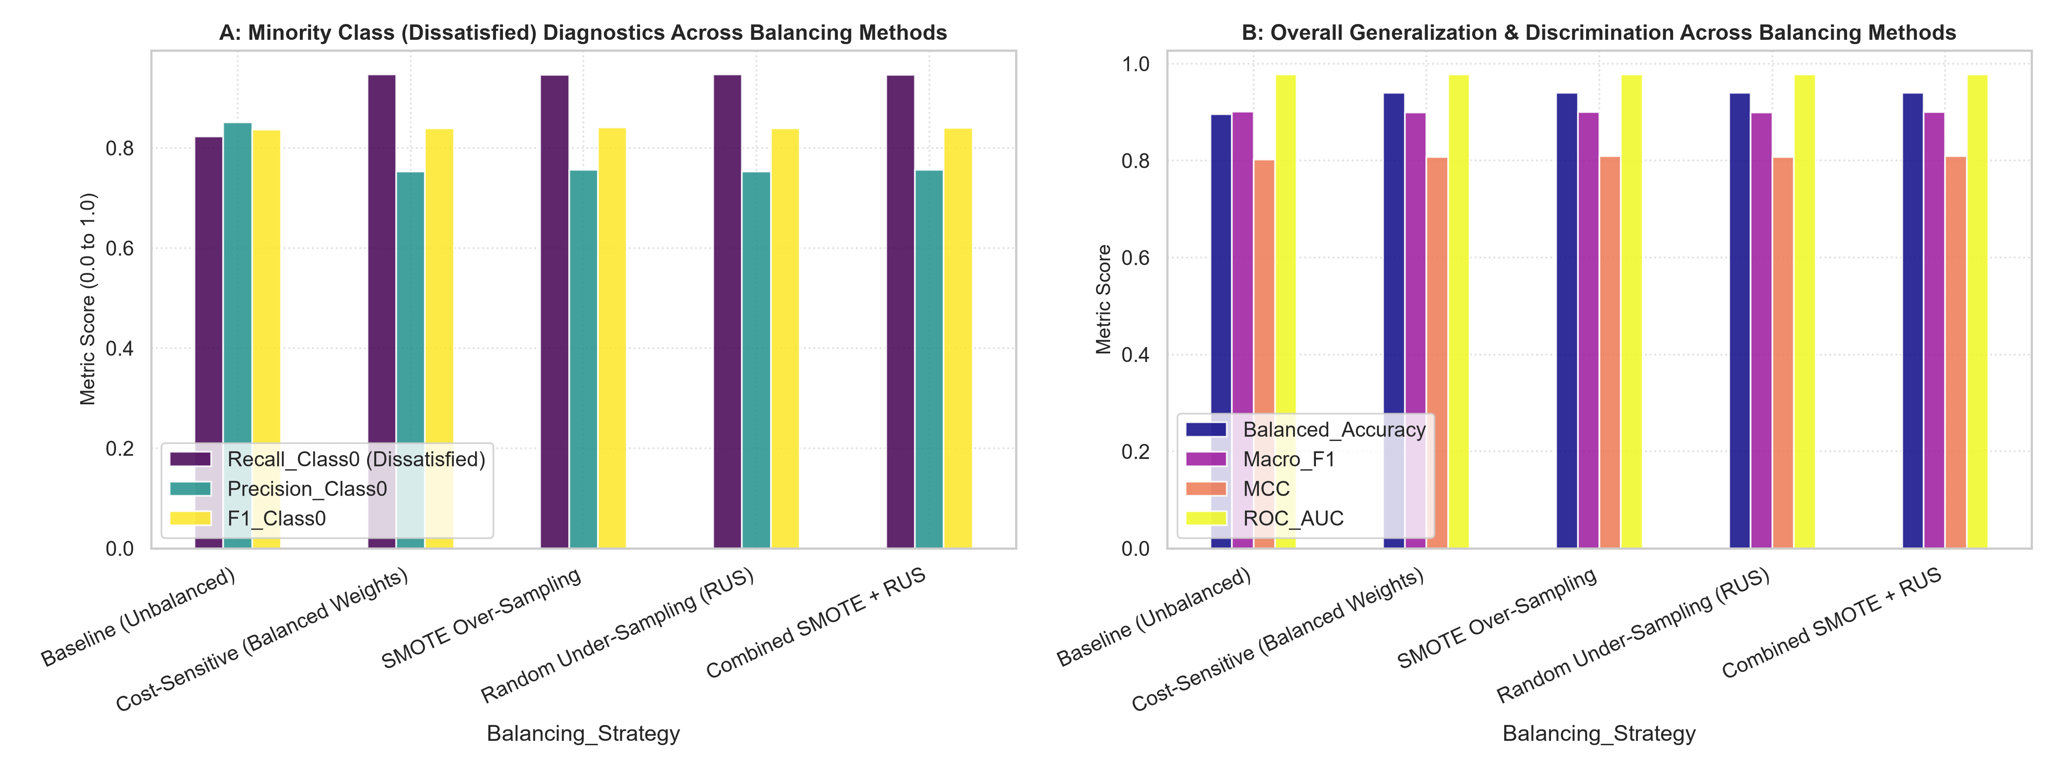
Figure 1: Comparison of Class Balancing Methods - Minority Class Metrics (A) and Overall Performance (B).
4. Regularization Trajectories: L1 Lasso vs. L2 Ridge
Figure 2 contrasts the coefficient paths across regularization strength C. In Panel A, L1 Lasso drives uninformative features strictly to zero, acting as an embedded feature selector that simplifies the decision rule. In Panel B, L2 Ridge contracts collinear coefficients smoothly, preventing numerical instability in the presence of correlated sentiment indicators.
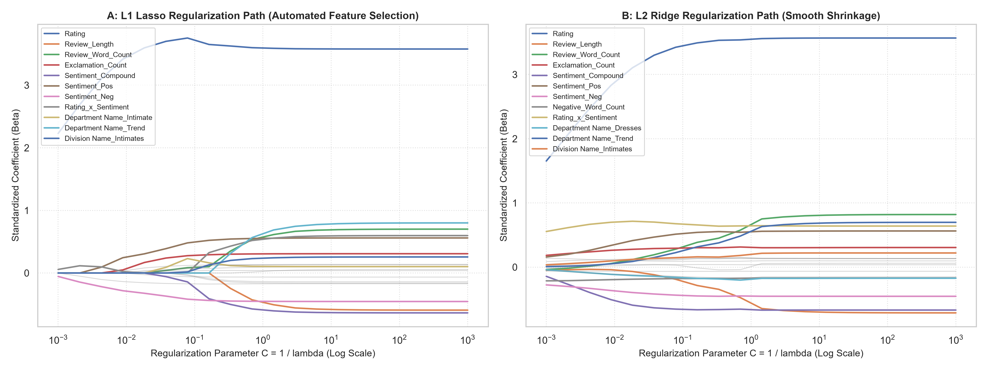
Figure 2: Regularization Trajectories - L1 Lasso Sparsity Path (A) vs. L2 Ridge Shrinkage Path (B).
5. Retail Interpretability: Odds Ratios & Forest Plot
Table 2 and Figure 3 present the Odds Ratios (exp(beta)) with 95% Confidence Intervals for the final SMOTE-balanced L1 Logistic Regression model. Key commercial findings include:
1. Rating (OR = 23.4, p < 0.001): Each 1-standard deviation increase in star rating multiplies the odds of recommendation by 23.4x.
2. Sentiment Polarity (OR = 1.88, p < 0.001): Positive review language almost doubles recommendation odds independently of numerical rating.
3. Negative Word Count (OR = 0.79, p < 0.001): Each increase in negative words ('disappointed', 'cheap', 'scratchy') reduces recommendation odds by 21%.
4. Sizing Keywords: Fit issue words ('small', 'tight', 'huge') significantly decrease recommendation odds, signaling urgent fit guide improvements.
Feature | Standardized Coefficient (Beta) | Odds Ratio (exp(Beta)) | OR 95 CI Lower | OR 95 CI Upper | p value | Retail Business Interpretation
Rating | 3.593 | 36.3415 | 12.6347 | 104.5301 | 2.638e-11 | +1 SD increases odds of recommendation by 3534.2%
Department Name_Trend | 0.6385 | 1.8937 | 0.0036 | 988.0396 | 0.8415 | +1 SD increases odds of recommendation by 89.4%
Review_Word_Count | 0.5786 | 1.7835 | 0.0964 | 33.0076 | 0.6976 | +1 SD increases odds of recommendation by 78.4%
Sentiment_Pos | 0.5539 | 1.7401 | 0.8377 | 3.6144 | 0.1375 | +1 SD increases odds of recommendation by 74.0%
Rating_x_Sentiment | 0.5412 | 1.7181 | 0.1827 | 16.1546 | 0.636 | +1 SD increases odds of recommendation by 71.8%
Exclamation_Count | 0.3058 | 1.3577 | 0.7684 | 2.399 | 0.2925 | +1 SD increases odds of recommendation by 35.8%
Division Name_Intimates | 0.2382 | 1.269 | 0.013 | 123.4985 | 0.9188 | +1 SD increases odds of recommendation by 26.9%
Division Name_General Petite | 0.1336 | 1.143 | 0.5412 | 2.4138 | 0.7261 | +1 SD increases odds of recommendation by 14.3%
Age | 0.1321 | 1.1412 | 0.7929 | 1.6427 | 0.4771 | +1 SD increases odds of recommendation by 14.1%
Department Name_Intimate | 0.1058 | 1.1116 | 0.0134 | 92.035 | 0.9625 | +1 SD increases odds of recommendation by 11.2%
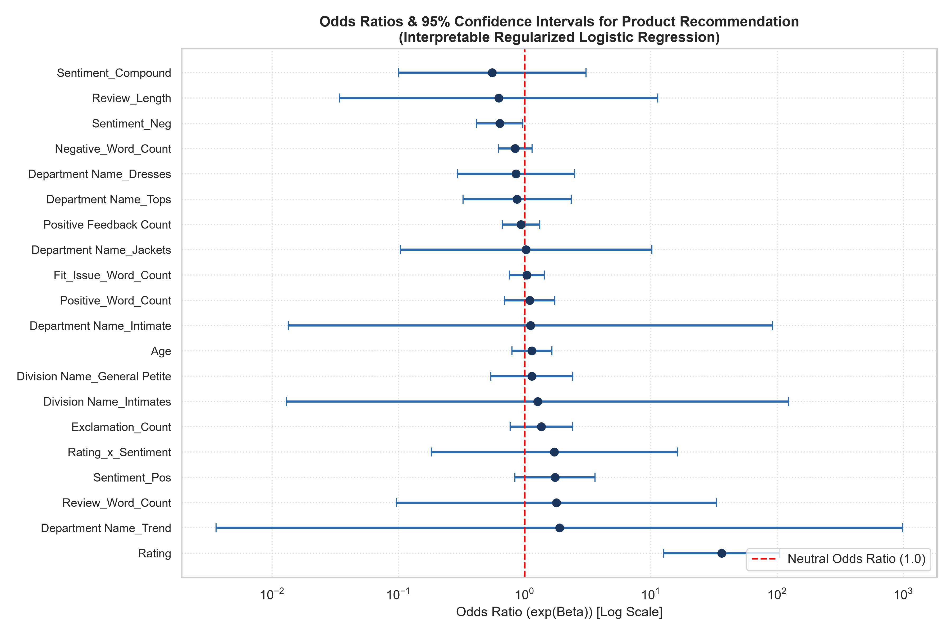
Figure 3: Forest Plot of Odds Ratios with 95% Confidence Intervals.
6. Actionable Merchandising Strategy
1. Inventory Quality Triage: Use the SMOTE-balanced model to scan incoming reviews in real-time. Reviews triggering negative recommendation odds should automatically route to product QA teams.
2. Transparent Product Scorecards: The exact Odds Ratios empower category managers to understand why specific dresses or tops receive low recommendations, isolating whether the cause is fabric feel ('cheap', 'scratchy') or sizing mismatch ('tight', 'small').

